Application Instructions for Nominated Exchange Students

- The nominated student will receive a validation email.

- Sign in with your email address and initial password
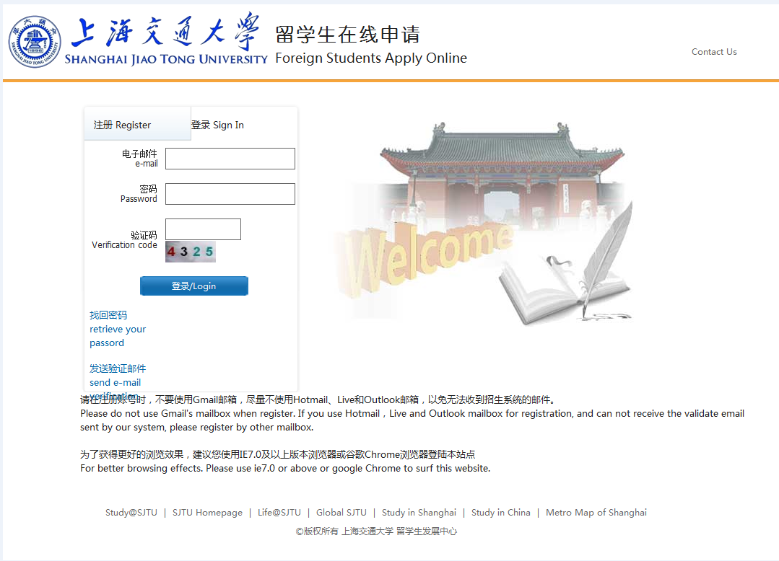

- Click “application”
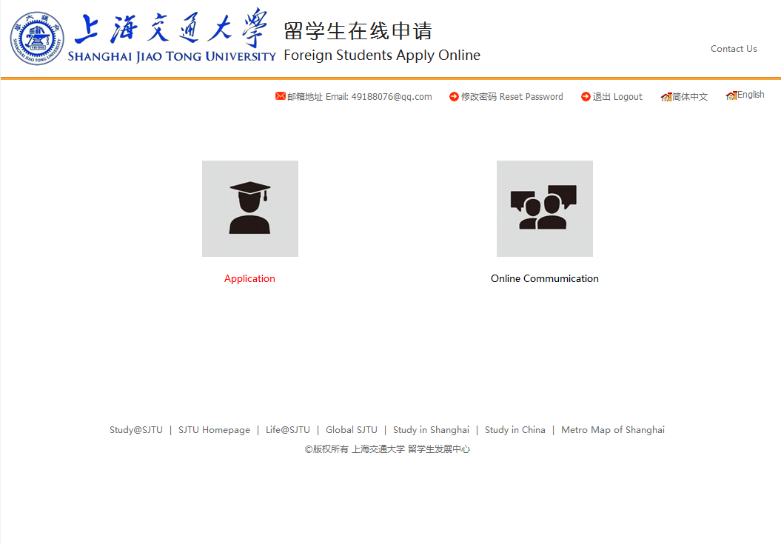

- Read the regulations and click “next”
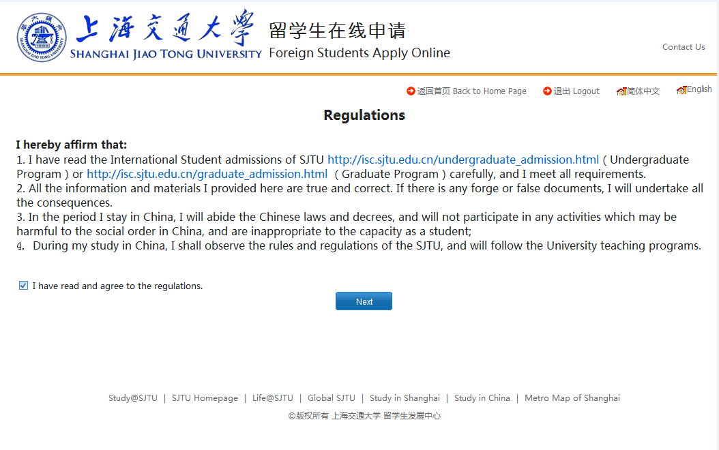
- Enter the “Application” and click “View”
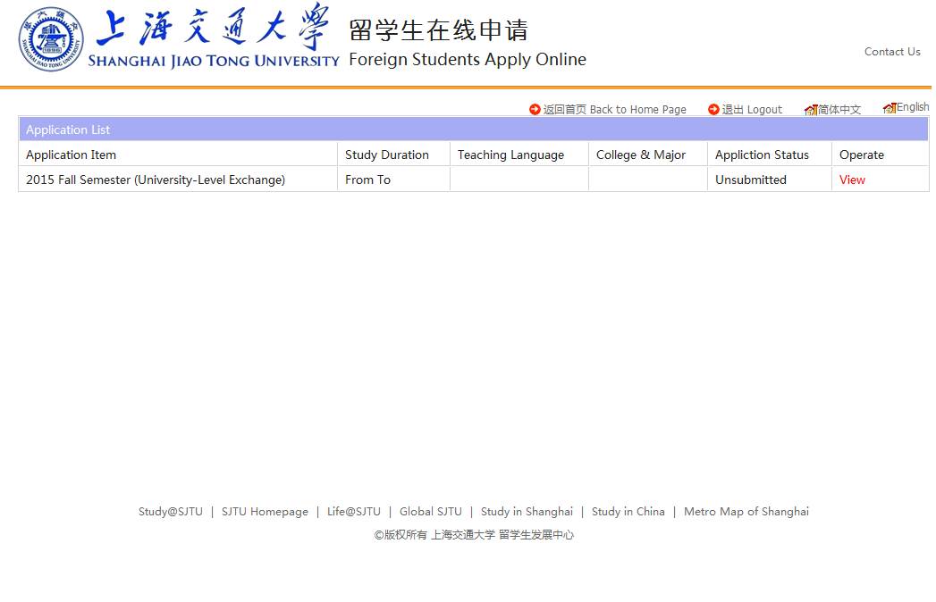

- Enter the “Application Form” and start from “Step 1”
- When you submit your application, you will get an email indicating that your application has been received.
- If your application is rejected or required for more information, you will receive an alert email and you need to go back to the application page for more information.
- If your application is accepted, you will get a congratulation letter.

